MEETING HELD ON PATENT COMMERCIALISATION

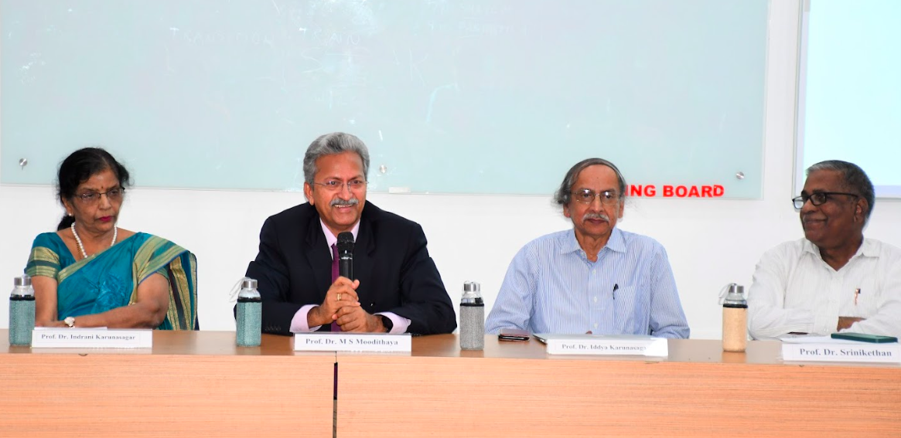

A meeting of patent applicants of Health Sciences institutions of Nitte University was held on 21 Aug 2023 at Chintana Hall, KS Hegde Hospital, Mangalore. About 20 patent applicants attended the meeting. Dr. Indrani Karunasagar, Director, DST TEC welcomed all the participants and highlighted the need to commercialise patents. Dr. M.S. Moodithaya, Vice Chancellor emphasized that this meeting was to create more awareness about business possibilities of intellectual property and the need to demystify this among academicians. He explained types of Companies that can be formed – proprietary, partnership, private limited and public limited. He urged the patent applicants to make use of the facilities Dr. Iddya Karunasagar explained about the policies of the University - Intellectual Property Rights and Technology Policy and Startup and Entrepreneurship Policy and how faculty could take advantage of the provisions. The participants asked for clarifications on the steps to avail pre-incubation and incubation facilities at Atal Incubation Center, Nitte. There was also discussion on the process of technology transfer to established companies. Dr. Iddya Karunasagar gave examples of technology transfer agreements executed previously and non-disclosure agreement before discussions about technology. Dr. Srinikethan spoke on behalf of AIC Nitte and the present status of incubates. He highlighted the need to have more faculty from Nitte institutions to avail incubation and seed fund facility at AIC Nitte.

